First meeting for sprint 2 (Team 77)

## Meeting date | time Date | Time | Meeting location Location

## 02/10/18 2pm-3pm 1hr online-discord (link: http://duscird.gg/CeyTQc)

|  |  |  |  |  |  |  |  |
| --- | --- | --- | --- | --- | --- | --- | --- |
| |  |  | | --- | --- | | Meeting called by | Keonwoo Lee | | Note taker | Keonwoo Lee | | Timekeeper | Keonwoo Lee | | Attendees  Keonwoo Lee, Dipper Dai, Yiming Pan, Anqi Cui  Non-Attendees  - |

Discussion Conversation

The purpose of today’s meeting is to discuss about how to start working on the sprint 2’s tasks and assign tasks to each other

**Finished (unexpectedly done) tasks during the mid-semester break**

* Creation of a prototype for “sign up” page
* Creation of a web page for “sign up” page
* Creation of text fields for sign up page – **need to develop more**
* Writing code to enable the text fields to be transferred into the database
* Writing code to show an error message if missing an important input field
* Writing code to avoid users signing up again with accounts already existing
* Writing test cases
* Story verification for story 5
* Creation of a prototype for the History/Data manage menu that has sorting functionality (dropdown list)
* Creation of dropdown lists

T**o do list for week10’s sprint 2 activities – focused on Story 24**

|  |  |  |
| --- | --- | --- |
| Action items | Person responsible | Deadline |
| **Topic 1** Create a from for the details to be entered for Story 24: History/Data Mange (Edit) (related to task ID T25) | Keonwoo Lee | 05/10/18 |
| **Topic 2** Create a prototype for the edit functionality  Verify story is complete (related to task ID T22,29) | Dipper Dai | 05/10/18 |
| **Topic 3** Create buttons “Edit and Save” and Write code to enable the button “Edit” for the edit functionality (related to task ID T23,24,26) | Yimming Pan | 05/10/18 |
| **Topic 4** Write code to enable the form to be transferred into the user’s database (by clicking the button “Save”) and write test cases (related to task ID T27,28) | Anqi Cui | 05/10/18 |

**Special notes Type additional notes here**

* The “sign up” page needs to be developed as there is a possibility that even customers can try signing up and have access to the company’s management system without having a special verification

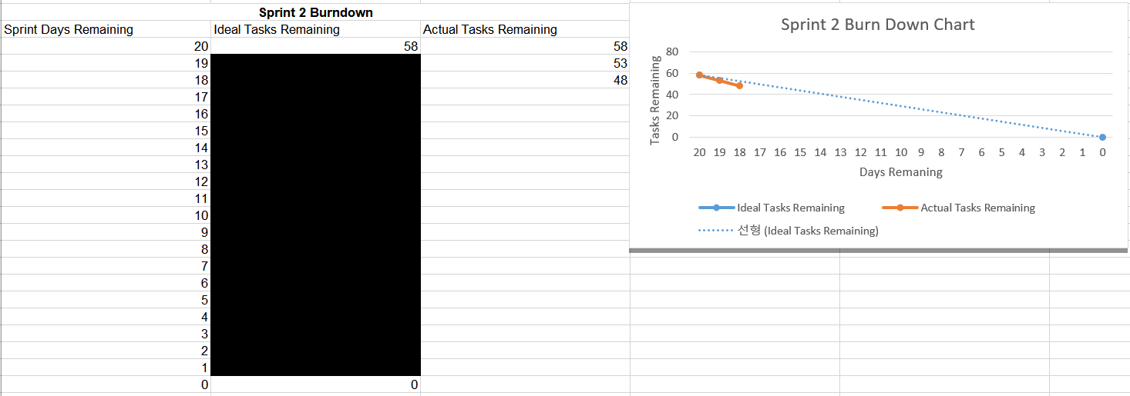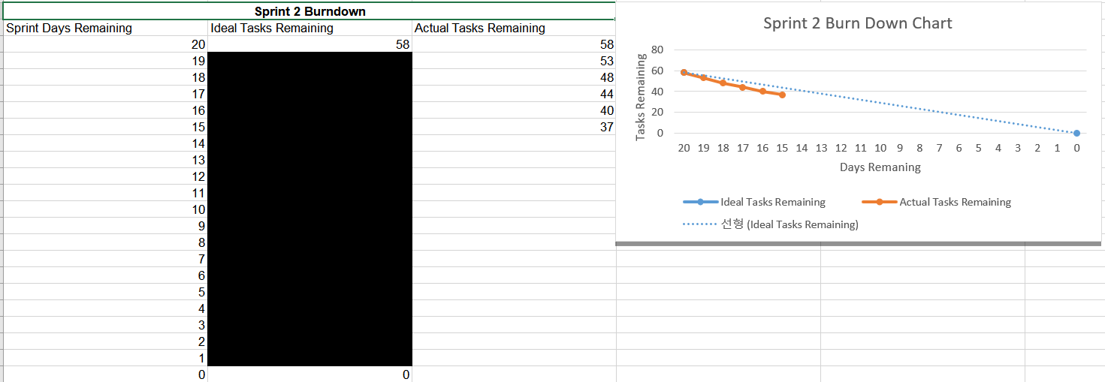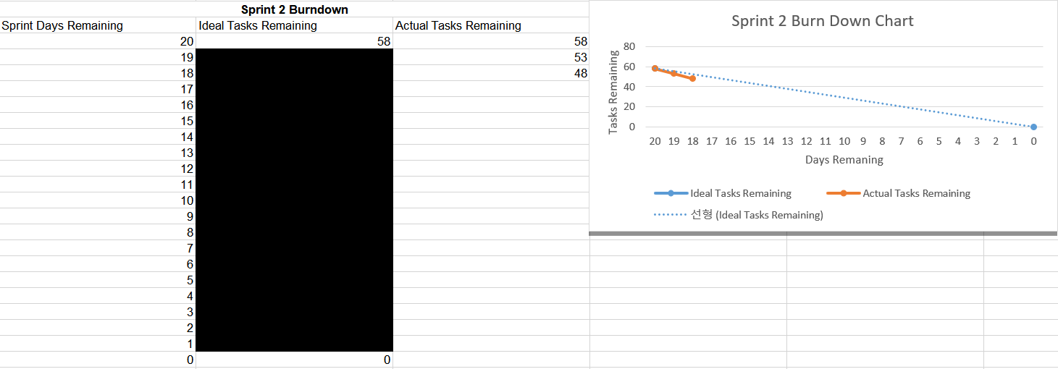**Burndown chart up to date**

**Next meeting:** 09/10/18Tuesday 2pm-3pm in S-block